Table of Contents
Table of Contents
1. Introduction 1
1.1. Purpose 1
1.2. Scope of Project 1
1.3. References 2
2. Overall Description 3
2.1. Product Perspective 3
2.2. User Classes and Characteristics 3
2.3. Design and Implementation Constraints 4
2.3. Requirement Specification 4
3.Requirements Specification 5
3.1. External Interface Requirements 5
3.1.1 User Interfaces 5
3.1.2 Hardware Interfaces 5
3.1.3 Software Interfaces 5
3.2. Functional Requirements 6
4. Nonfunctional Requirements 7
4.1. Performance requirements 7
4.2. Safety requirements 7
4.3. Security requirments 7
4.4. Software Quality requirements 8
5. Use Case Diagram 9
6. Class Diagram 10

1. Introduction

1.1. Purpose
The purpose of this system to let students from any part of the world to have access to advanced courses by Top Universities and Companies. Students will gain plenty of knowledge and skills by learning through this system. The internships and job opportunities will be given to those who will successfully complete the course. There are also specialization courses.

1.2. Scope of Project
This software system will be a perfect learning platform for the global. This system will be easy to register and can be accessed by anywhere around the world and students can learn any courses they prefer. The video lessons, assignments for students and quizzes can be uploaded by University, Company and instructors who have done partnership with the system.
More specifically, this system consists of question and answer forum for each course where students can interact and communicate with other students but they cannot ask professors directly. This system is designed to allow students to reset deadlines. After completing the course, the system will generate scores and grade for each course and generate certificate where students can connect with their LinkedIn profile. This system can also recommend courses according to their past courses records. There are mainly five user types in this system. They are students with education mails, personal mails, students who audit and instructors from Universities and Companies. They have different roles and system has different services for them.
For the student user, they will gain plenty of knowledge and skills by using this learning platform. They can also increase job opportunities and easy to secure jobs. It is also flexible since this is online learning tool. For instructors from Universities and Companies, they can earn money by teaching online. For Companies, it is easier to find interns.

1.3. References
IEEE. IEEE Std 830-1998 IEEE Recommended Practice for Software Requirements Specifications. IEEE Computer Society, 1998.

2. Overall Description

2.1 Product Perspective
- The web pages (XHTML/JSP) are present to provide the user interface on customer client side.
- Communication between customer and server is provided through HTTP/HTTPS protocols.
- The Client Software is to provide the user interface on system user client side and for this TCP/IP protocols are used.
- On the Server side web server is for EJB and database server is for storing the information.
There are some learning platform system but this one has some features that can't found on other systems like getting internship right after completing the specific courses. These kinds of systems are common and easy to access from developed countries but this system will be the first in Myanmar.

2.2 User Classes and Characteristics
Users of the Global Online Learning Platform can be any person who is interested in having online lectures, participating in question and answer forum. Mainly we can categories the users as students with education mails, students with personal mails, students who take audit, instructors and professors from Universities and Companies, the finance management and the administrator.
Students with Education Mails: Every student with education mail can access the courses free which are sponsored by their Universities. They can view video lectures, read notes, attempt quizzes and take assignments. They can also communicate with other students through question and answer forums. They can receive certificates which can be shared on LinkedIn after successfully complete the course.
Students with personal Mails: They can view video lectures, read notes, attempt quizzes and take assignments. They can also communicate with other students through question and answer forums. They can receive certificates only if they paid for the course and that certificate can be shared on LinkedIn after successfully complete the course.
Students who audit: They can view video lectures, read notes, attempt quizzes and take assignments. They can also communicate with other students through question and answer forums. They cannot get certificate after completing the course.
Lectures and Professors from Universities: They can upload video lectures and create notes, assignments and quizzes by using this system. They can earn money from the students who paid for their courses.
Lectures and Professors from Companies: They can upload video lectures and create notes, assignments and quizzes by using this system. They can earn money from the students who paid for their courses. They can also find good candidates and interns for the companies.
The Finance Management: The finance management is responsible for maintaining the financial details of the users registered for various courses. They manage the sponsorship fees from University, courses fees from students and agency fees from Companies who need interns.
The Administrator: As admin, they have the task of maintaining the system such as maintaining the database, performing regular backups, keeping the system running and handling any failure of the system.

2.3 Design and Implementation Constraints
- Cloud storage that can hold many databases will be used.
- Streaming platform for video lectures.
- Shared server where one server is used by multiple people.
- Android users will need at least android version 3 and above.
- IOS users will need at least iOS version 4 and above.
- Need to connect with third party application such as LinkedIn and PayPal.
- MYSQL Server will be used as SQL engine and database.
- Java Spring Boot with version 2.7.3 and above will be used.
- Users may access from any computer that has Internet browsing capabilities and an Internet connection.
- Users must have their correct usernames and passwords to enter into their online accounts and do actions.

3. Requirements Specification

3.1 External Interface Requirement
3.1.1. User Interfaces
Login Interface: In case the user is not registered yet, he can enter the details and register. Which asks the user to type his username and password. If the user entered his username or password incorrectly then an error message occurs.
After Login Interface: The UI after login will be different for four types of users such as students with education mails, students with personal mails, Universities and Companies. Students will reach to catalog page where many courses can be preview. Universities and Companies will reach to upload course page.
Search: The students can enter the type of course they are looking for and type the keywords of the course in the search bar. The system will show the recommended courses.
Categories view: Categories view shows many kinds of subjects and they can choose what they like. They courses are programmed to learn form basic to professional.
Course Detail view: The students can decide whether they will enroll or not based on the detailed views provided by the system.
After Enrolled view: They will reach the course outline after enrollment and have access to lecture videos and notes. After learning videos, they can attempt quizzes and take assignments. The deadlines for each course will be shown.
Discussion Forum: They can ask questions freely and other students can answer and interact with each other.

3.1.2. Hardware Interfaces
Only the recommended configuration (basic requirements of a computer system) no other specific hardware is required to run the software.

3.1.3. Software Interfaces

Browser to load and view web pages
Operating System

3.2 Functional Requirement
1. User class 1(Students)
(a) Browse course catalog
(b) Enroll courses
(c) Submit quizzes and assignments
(d) Reset deadline if needed
(e) View and upload profile
2. User class 2(Universities)
(a) Upload videos, quizzes and assignments
(b) Paid sponsor fees to this system for their students
(c) Generate scores and grades
3. User class 3(Companies)
(a) Upload videos, quizzes and assignments.
(b) Paid agency fees to get interns for their company.
(c) (c) Generate scores and grades
4. User class 4(Finance Manager)
(a) Manage money transfer with PayPal
(b) Manage financial transactions

5. User class 5(Administrator)
- View requests
- Manage requests
- Manage emails
- Backup Database
- View user activity logs
4. Nonfunctional Requirements

4.1 Performance Requirements
The application should be able to operate on all major web-browsers with all of its
fundamental functions. It should not slow-down the system even at peak hours without
affecting the quality of service of the system.
The application should be able to operate on all major web-browsers with all of its
fundamental functions. It should not slow-down the system even at peak hours without
affecting the quality of service of the system.
The application should be able to operate on all major-browsers with all of its fundamental functions. It should not slow down the system eve at peak hours with affection the quality of service of the system.

4.2 Safety Requirements
- The data of users are protected by the system where the user can view only his profile.
- The grades, scores and certificates can be share depends on his will.
- All money transactions can be done with many steps in order to secure money.

4.3 Security Requirements
- The server on which the Global Online Learning Platform will have its own security to prevent unauthorized write/delete access.
- The system should provide a secure login to the users by using advanced secure login algorithms and provide access only to the authorized users as security is the key requirement of this system.
- The user ID and the password should not be shared with anyone.

4.4 Software Quality Attributes
Reliability
The video quality should be clear and good. The audio could be heard well. The video and audio of lectures should be synchronized well.
Availability
Always available so that student can use it at any time according to his convenience.
Scalability
Numbers of users supported in this class will mainly depend on the server load, server processing capacity and its memory. It should scale maximum number of users.
Security
HTTPS enables access to web application to secure access to confidential data(student information). Database Access, there will be no external access to the database, except through the XML protocol. Administrators of the system will have full database rights and Lectures may have access to a copy of parts of the ELS database, for editing proposes.

5. Use Case Diagram

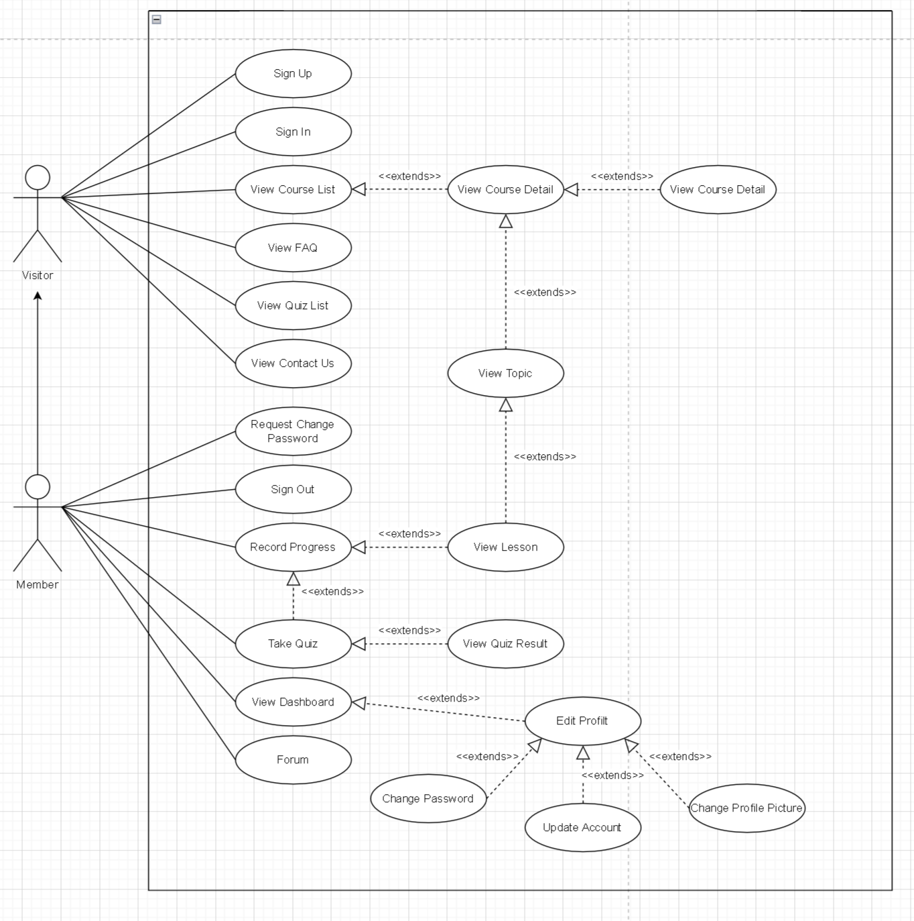

Figure 5.1 Use Case Diagram for Global Online Learning Platform

6. Class Diagram

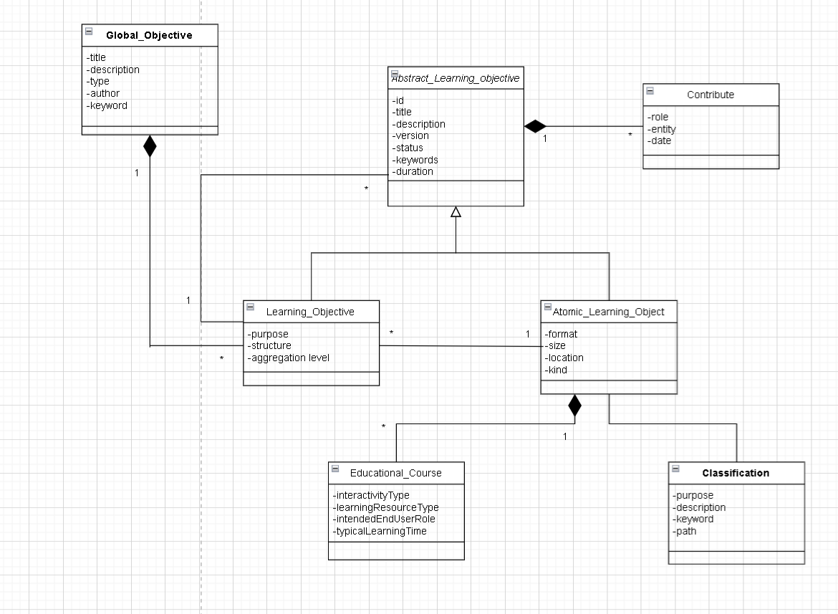

Figure 6.1 Class Diagram for Global Online Learning Platform

